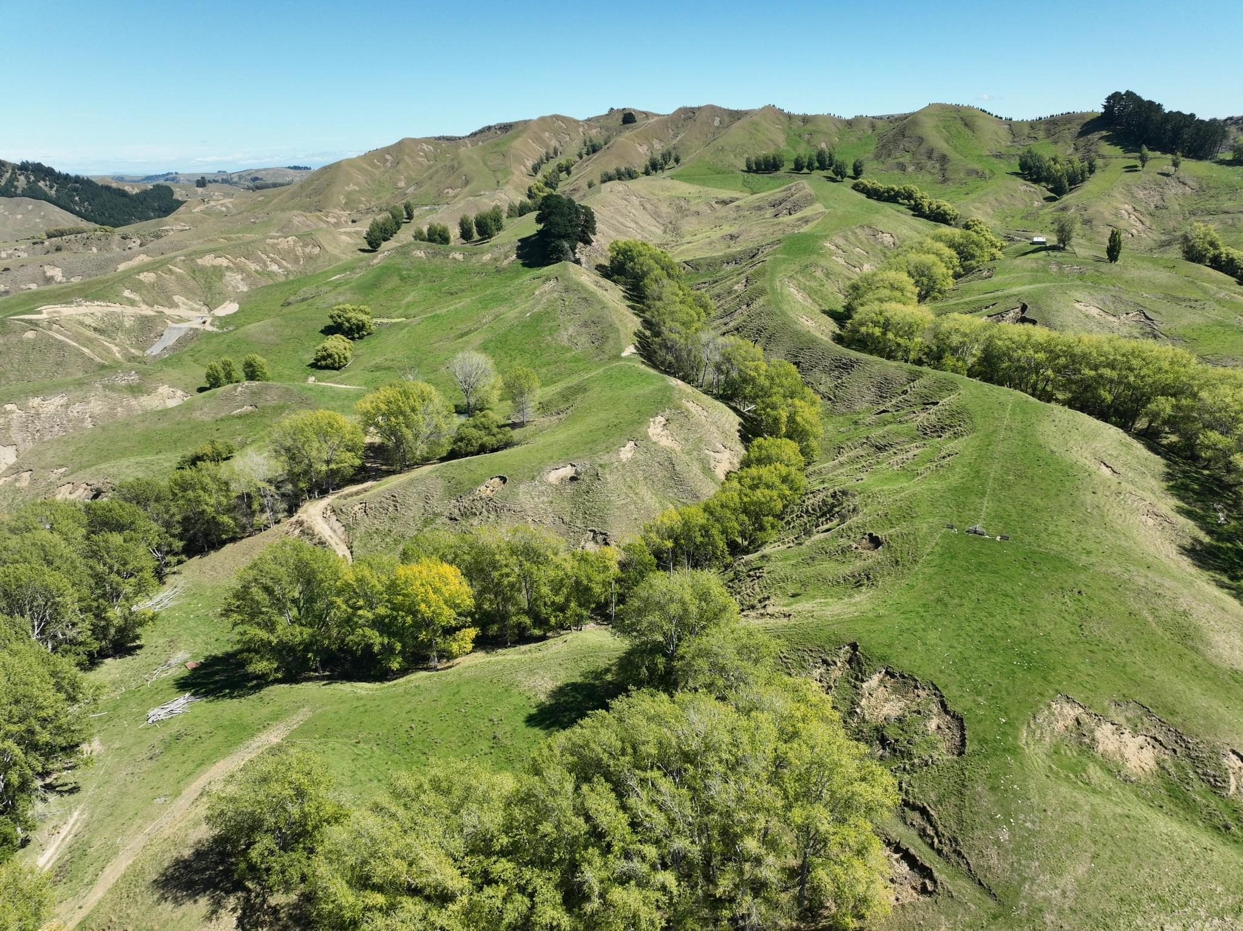
HĀWEA
SUB-CATCHMENT PLAN DRAFT
TLC The Big Picture: Tackling the big issues sub-catchment by sub-catchment


CONTENTS

TUKITUKI CATCHMENT: THE BIG PICTURE 3
1. Introduction to The Big Picture 3
1.1. Purpose of The Big Picture 3
1.2. Freshwater status of the Tukituki catchment 4
1.3. Approach: creating priority actions in the Tukituki 4
2. Tukituki’s Overall Big Picture 5
2.1. Summary of sub-catchment challenges and priorities 5
2.2. Outcome areas most sought by farmers (from workshops) 6
3. The Hāwea Catchment Context 7
3.1 Background 7
3.2 Hāwea Catchment Context 8
3.3 Catchment Challenges and Key Focus Areas 9
4 Landscape Context 10
5 Summary of Challenges, Impacts and Priority Actions 11
6 Hill Country Erosion Approaches 11
6.1 The cost of erosion in the farming landscape 12
6.2 The estimated cost of erosion in the Hāwea 12
6.3 Effectiveness of options for recovery of highly eroded areas 12
6.4 Summary of the Effectiveness of Hill Country Erosion Tactics 14
7 Hāwea Conclusions and next steps 15
1. Appendix 1- TLC On-Farm Action Planning Tool 16
16
2 Appendix 2 - Understanding Highly Erodible Areas 17
2.1 Highly erodible areas using mapping 17
2.2 Farm planning using RUSLE 18
3 Appendix 3 Flow mapping to understand sites for sediment trapping 18
3.1 Identification of sites for edge of field mitigations (wetlands, bunds, dams) 18

TUKITUKI CATCHMENT: THE BIG PICTURE

Introduction to The Big Picture

Purpose of The Big Picture
In 2024 Tukituki Land Care (TLC) launched The Big Picture, a six-month project designed to create independent, science-based catchment plans for the 17 sub-catchments of the Tukituki River in Central Hawke's Bay. The initiative identified each sub-catchment's unique environmental challenges and developed practical, cost-effective solutions to address them. As TLC Chair Richard Hilson explained, "We tackled the big issues sub-catchment by sub-catchment, to piece together the bigger picture."
The project employed a comprehensive research approach that combined field investigations, insights from local farmers, and an in-depth analysis of existing studies and data on the Tukituki catchment. Environmental planning consultancy, Environment, Innovation and Strategy Ltd (EIS), led by Matt Highway, undertook this work.
This project reflects TLC's dedication to improving environmental health and farm productivity, paving the way for a sustainable future for the Tukituki community.
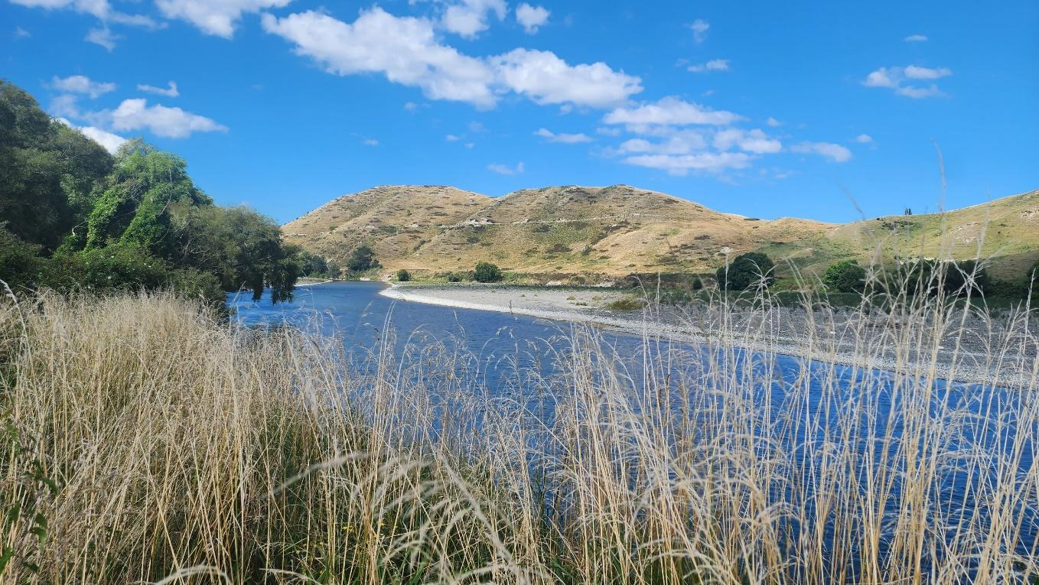

Freshwater status of the Tukituki catchment

Summary of State of the Environment reporting
The Tukituki catchment faces water quality, land use, and climate challenges. The catchment, dominated by sheep and beef farming, has experienced significant modifications, leaving only about 10% of its land covered in indigenous vegetation. Water scarcity is a persistent issue, with decreasing river flows over the past three decades, exacerbated by droughts and climate change. Groundwater levels in the Ruataniwha Plains are under strict management to prevent further decline, but interannual variability and climate change pose ongoing risks.
Water quality is a major concern due to high levels of nitrogen, phosphorus, and sediment. The highest nitrogen concentrations in the region occur in streams draining the Ruataniwha Plains, and some areas exceed nitrogen targets by two to four times. Phosphorus and fine sediment issues, linked to erosion, contribute to poor water clarity and degraded aquatic habitats. Toxic algae, particularly Phormidium cyanobacteria, can proliferate in the river during low summer flows, posing a risk to both human and animal health. Despite these issues, the Tukituki River remains generally swimmable, except after heavy rainfall when contaminant levels rise.

Approach: creating priority actions in the Tukituki
The Big Picture project adopted a highly collaborative approach involving detailed catchment research, GIS mapping, and farmer engagement. Workshops were conducted with local farmers in each sub-catchment to better understand group dynamics, gather community values, and identify key issues and opportunities. Feedback from the workshops, survey results, and field investigations have been used to shape tailored catchment plans aligning with the local communities' specific landscape context and aspirations.
As part of the implementation phase, TLC introduced "THR3E"—three actionable steps designed for farmers in each sub-catchment to implement over three years. The TLC Farmer Toolbox was also launched, providing practical resources to help landowners make informed decisions and maximise the impact of their efforts. Additionally, monitoring strategies are to be implemented, and demonstration sites will be identified to help showcase best practices, ensuring that the plans remain relevant and actionable.
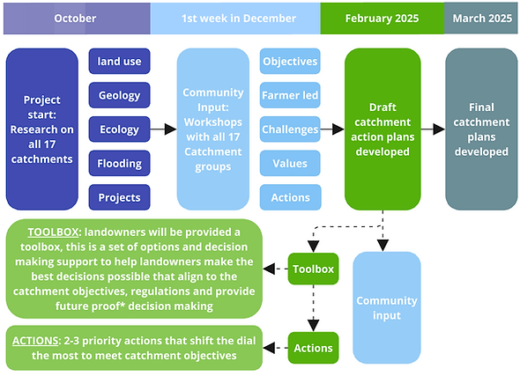

Tukituki’s Overall Big Picture

Summary of sub-catchment challenges and priorities
The Big Picture project team has worked with farmers to identify challenges and opportunities in each of the 17 sub-catchments. While each sub-catchment has an individual plan, it is the big picture of the people, the land and the water within the Tukituki that we are trying to collectively support. The approach is reminiscent of a jigsaw puzzle where many pieces fit together and form something greater than themselves as an individual piece. Figure 1 below shows how the Tukituki sub-catchments fit together as a big picture, showing the sub-catchments that are aligned in similar top priorities. Note that the image only shows the proposed highest recommended priority area for each catchment, and all catchments will have multiple outcomes they are seeking.
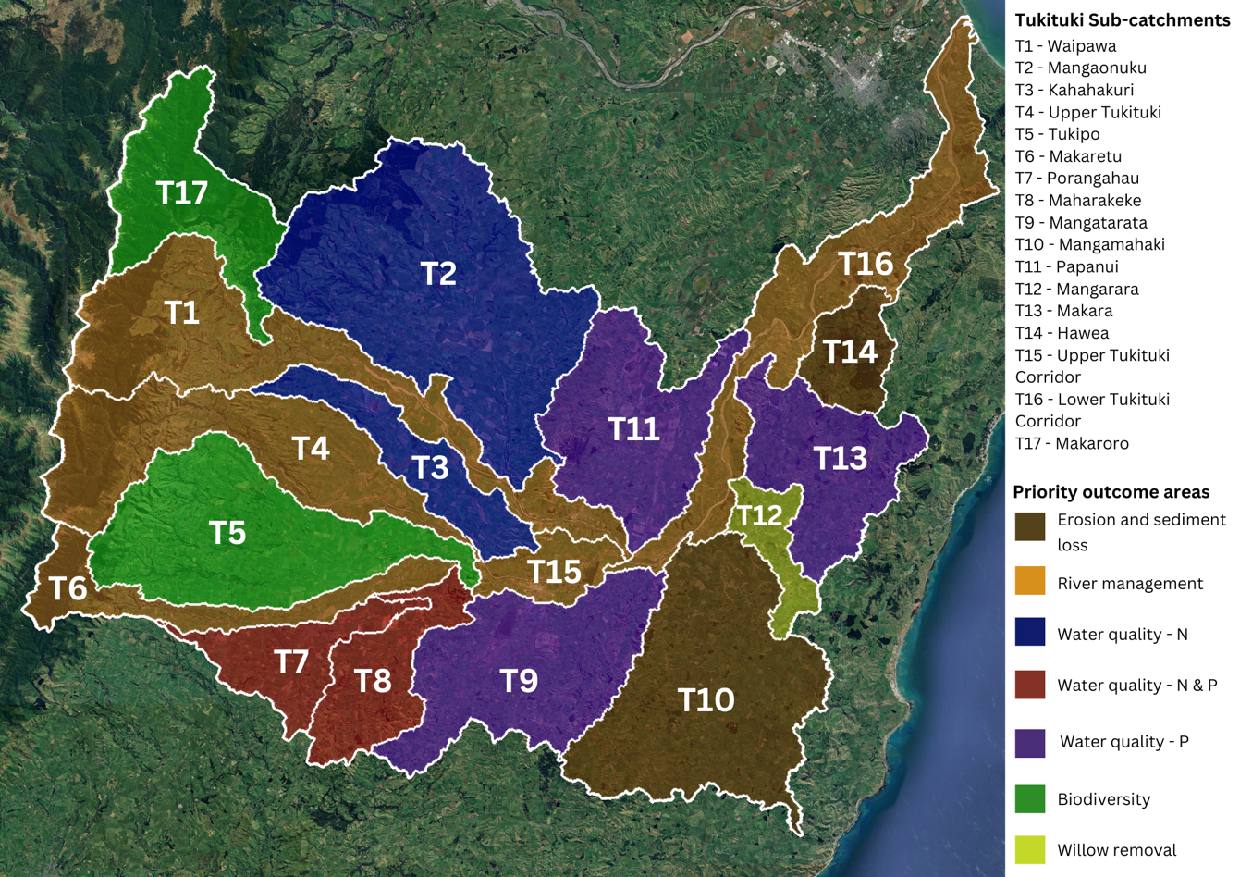
Figure 1 – Sub catchment map for the Tukituki. Coloured areas highlight the recommended priorities for each catchment.

Outcome areas most sought by farmers (from workshops)
During workshops, farmers were asked to vote on a selection of outcome areas. Below are the top five outcomes:
- Support landowners with the knowledge to make informed decisions to improve the environment.
- Improve the flood resilience of the catchment, including upstream and downstream to reduce effects on the community in adverse weather events.
- Protect and enhance the economic viability of the area.
- Protect and enhance the quality, ecology, mauri of waterways and wetlands.
- Represent farmers interests in future regional government setting of rules and regulations.

HĀWEA CATCHMENT: CONTEXT AND CHALLENGES

3. The Hāwea Catchment Context

3.1 Background
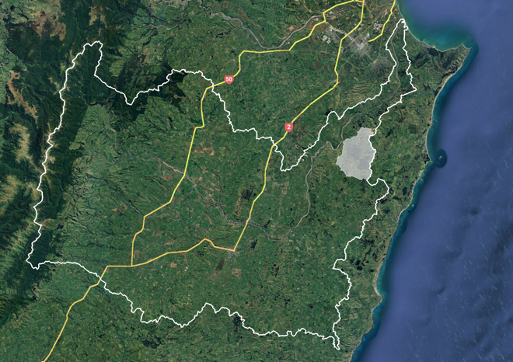
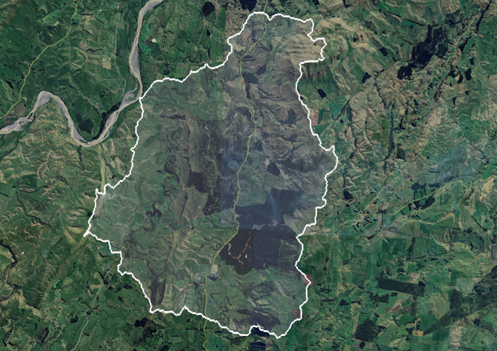
The Hāwea Catchment is located on the eastern border of the Tukituki catchment (Figure 2). The catchment includes a mix of land uses, with pastoral farming in 70% of the catchment and Pinus radiata forestry blocks on the remainder.
Figure SEQ Figure \* ARABIC 2: Location of the Hawea catchment in the wider Tukituki.
Figure 2 - Location of the Hāwea catchment in the wider Tukituki
Erosion and sedimentation are significant challenges across the catchment, partly due to aging poplar and willow plantings established in the 1960s and 1970s. Over time, inadequate maintenance has led to instability in these "old man" poplars, increasing the risk of tree falls, flood debris, and associated safety hazards. However, despite these issues, poplars continue to be a valuable tool for erosion control, providing benefits such as soil stabilisation, sediment reduction, and potential timber applications.
Recognising the multifunctional value of poplars, members of the Hāwea catchment, with support from a TLC Demonstration Grant, are working to shift the perception of these trees from liabilities to assets. As part of the TLC Demonstration project, they have shared knowledge on repurposing fallen and obstructive poplars and provided education on best practices for future poplar planting and on-farm utilisation and processing of older trees.
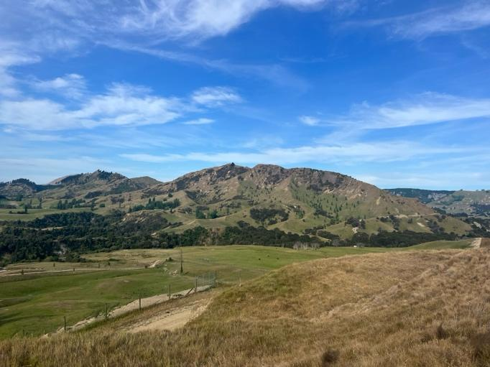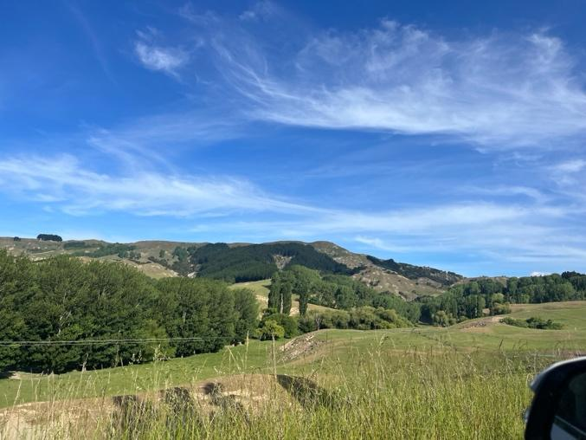

3.2 Hāwea Catchment Context
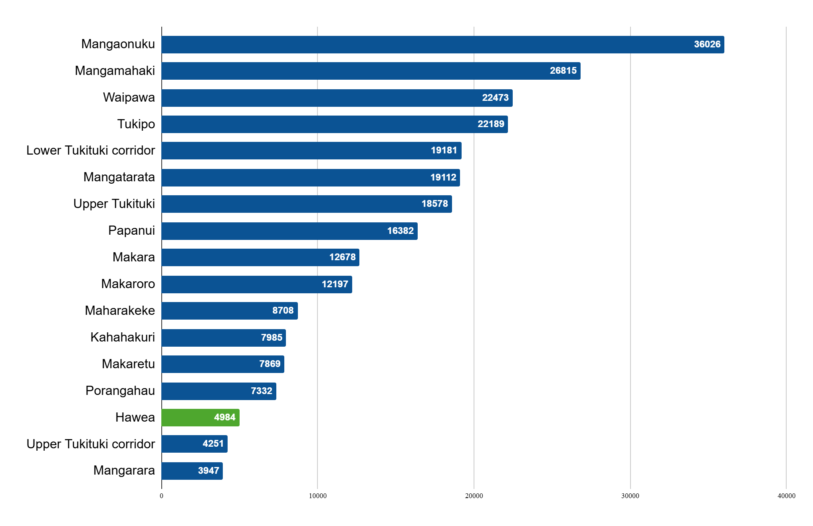
Figure 3 – Tukituki sub catchment areas in hectares.
The Hāwea catchment is 4,984ha in size which amounts to 1.99% of the 250,000ha Tukituki catchment (figure 3).
Land use in the Hāwea is not unlike other parts of the wider Tukituki catchment, with 70% of the catchment in pasture, 26% in exotic forest and less than 3% of land cover in native vegetation (figure 4).
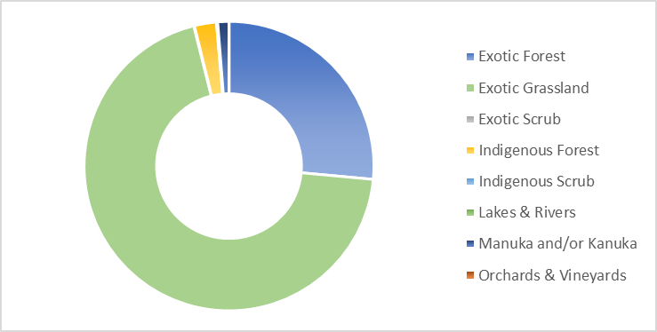
Figure 4: Land use in the Hāwea catchment.

3.3 Catchment Challenges and Key Focus Areas
Being one of the smallest sub-catchments, Hāwea has only a few landowners. While there is no formal catchment group for the Hāwea sub-catchment, it is well represented by a landowner active in catchment management. Discussions at the December 2024 Big Picture workshops highlighted key concerns, particularly the aging and poorly maintained poplar and willow plantings along waterways. These trees, spanning approximately 14ha across multiple properties, were identified as a persistent issue requiring removal.
Preliminary discussions have explored the potential for milling the trees, utilising woodchips, and identifying market opportunities both locally and for export. However, these remain initial conversations, and no formal market feasibility study has been conducted.
A summary of key water quality indicators for the Hāwea, (currently measured within the Makara Catchment), based on a five-year rolling average, is provided in Table 1. While nitrogen and sediment levels are within acceptable thresholds, phosphorus levels exceed the standard, and freshwater invertebrate health (MCI index) is notably low. Further details are available via the Hāwea Dashboard.
Table 1 - Hāwea catchment water quality indicators over a five-year rolling average, note these measurements are taking from within the Makara sub catchment. * The standard represents water quality levels based on the Tukituki plan or national standards. See Link to the Hāwea dashboard for more information.
Water Quality Parameter | Hāwea | Standard*
Nitrogen (DIN) | 0.161 mg/ L | 0.8
Phosphorus (DRP) | 0.028 mg/ L | 0.015
Bacteria (E.coli) | 140 (count) | 260
Freshwater invertebrates (MCI) | 56 (index) | 100
Sediment (Turbidity) | 3.1 mg/ L | 5.6 FNU (light)

4 Landscape Context
The Hāwea Catchment is primarily composed of hill country farmland, including areas of very steep terrain. The underlying geology consists predominantly of mudstone and claystone (Figure 5 – right), making the landscape highly susceptible to erosion.
A desktop analysis indicates that most of the catchment is at risk of erosion, with certain areas in the northwest exhibiting significantly higher susceptibility compared to the rest of the catchment (Figure 5 – left). The resulting sediment loss has several adverse effects, including degraded water quality, increased flood risk, damage to infrastructure, and the loss of productive land. Addressing these erosion challenges will be critical to maintaining both environmental and economic sustainability in the region.
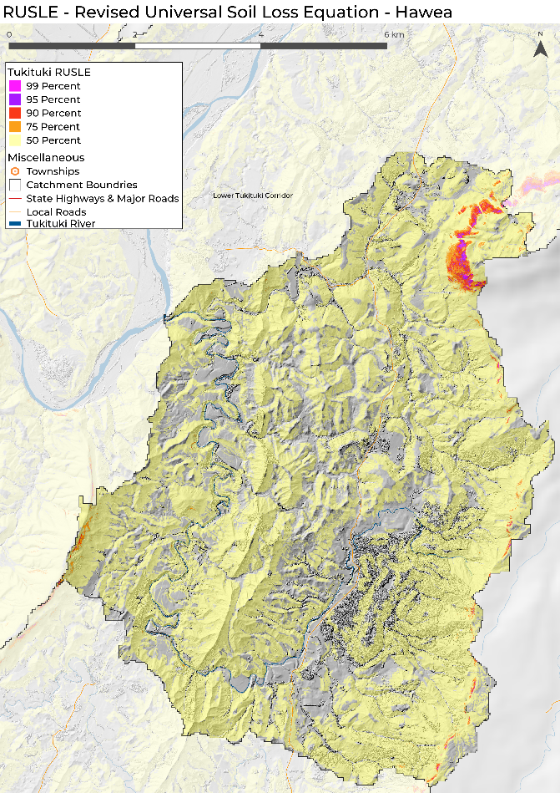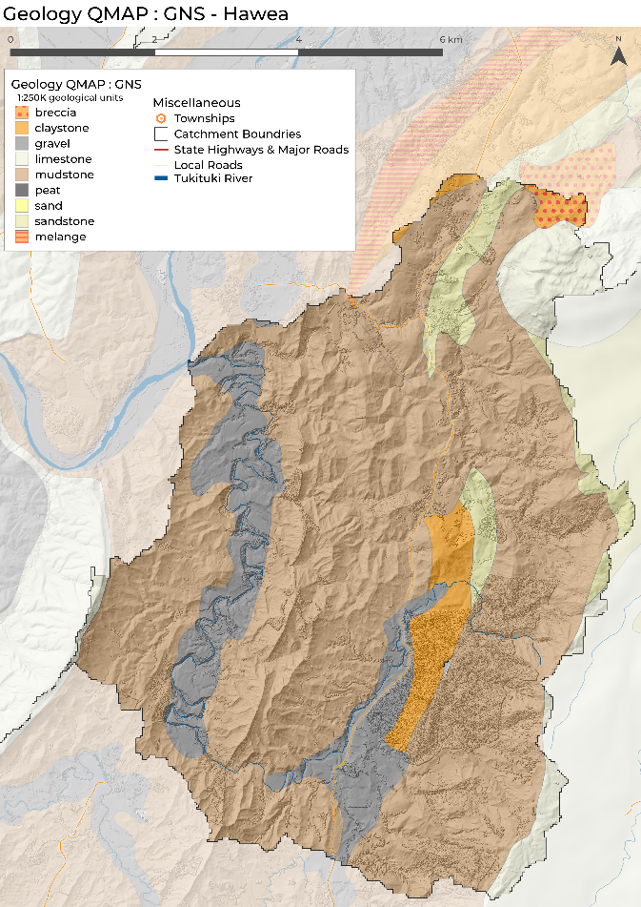
Figure 5 – LEFT. Highly erodible land model for the Hāwea using RUSLE. It will come as no surprise to the landowners in the catchment that there is a significant amount of highly erodible land, with most of the catchment in the top 50% of erodible land in the Tukituki. RIGHT. Geology of the Hāwea, dominated by highly erodible mudstones.

HĀWEA CATCHMENT: DECISION MAKING SUPPORT

5 Summary of Challenges, Impacts and Priority Actions
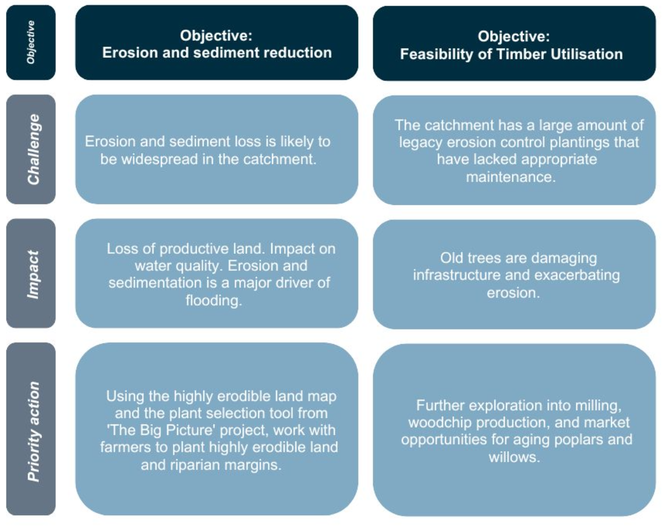
Figure 6 - Summary of the challenges, impacts and recommended priority actions for the Hāwea Catchment, framed against the two major objective areas

6 Hill Country Erosion Approaches
Given that the Hāwea catchment group is small and still forming, the below information is compiled to support decision making around hill country erosion, which appears to be the highest priority. Once the community has investigated and developed objectives, new decision-making tools can be developed around those.

6.1 The cost of erosion in the farming landscape
The productive and economic cost of erosion can be high. Research undertaken on Wairarapa slip sites observed that pasture production on erosion scars took 20 years to reach a level 70-80% of that on uneroded sites, and subsequently levelled off at 80-85%.
Manaaki Whenua Landcare Research reviewed the marginal cost of erosion (negative impact on productivity) and stated that the cost ranges between $0.03 and $5.61 per tonne of soil lost, with a mean value of $1.80 per tonne, depending on land use. The highest marginal cost of aggregated erosion was experienced in vegetables, fruit, and dairy land uses, while the lowest marginal cost of aggregated erosion was experienced in exotic forestry, sheep and beef, and other pastoral land uses. The high erosion cost for horticulture is mainly driven by the high annual net revenues ($7–9 k/ha). Sheep and beef, and exotic forestry are often located in marginal land with relatively low annual net revenues, and therefore the marginal impact of erosion was lower.

6.2 The estimated cost of erosion in the Hāwea
Using the above estimates of costs for sheep and beef farming, the modelled 6.5 t/ha/year sediment loss and the catchment size, it is possible to estimate the annual cost of soil loss to the Hāwea community through the following equation:
= (average cost per tonne x tonnes per ha) x total hectares
= ($1.80 x 6.5) x 4,984 = $58,180 loss in income due to erosion per year in the Hāwea catchment.

Note that the above estimate is based on large assumptions, primarily the use of SEDNET modelling and the use of national average figures. This cost figure is indicative only and will vary drastically from year to year.

6.3 Effectiveness of options for recovery of highly eroded areas
Fencing and sowing legumes: Rapid establishment of productive pastures on erosion scars in Wairarapa and similar hill country can be achieved by retiring areas from grazing for 2-3 years, and oversowing with white clover and lotus⁵.
Over sowing legumes only: Where spelling from grazing is not an option, significant (but reduced) improvements in rate of slip revegetation and subsequent productivity can be made through oversowing white clover seed⁵.
Fencing and native afforestation: Significant reduction in erosion, up to 74% less slips occur in native forest compared to pasture. Native species are a great long-term approach but can be very costly and hard to establish in dry exposed hill country. Hardy species like mānuka and kanuka have been used in the past as an initial coloniser species to increase canopy cover and reduce costs. This has been used for decades in New Zealand and more recently described as the Tīmata method in an Our Land and Water project.
Space planted poplars: Space planted poplars are one of the most common forms of slope stabilisation in New Zealand and are readily accessible through regional council soil conservation programmes. During cyclone Bola land planted with space planted trees had 22% less erosion than pasture areas without trees⁷.
Afforestation with pines: Established pine forest had 87% less erosion scars than pasture alone in the Manawatu events in 2004. However pine trees have limited benefit in gully erosion and for stabilising stream banks⁷.
Space planted kanuka: A study on a Hawkes Bay farm found 108% more pasture growth under kanuka trees on sloping summer dry hill country pastures compared to open pasture. The study found: 49% more organic matter, 116% more Olsen-P and 9% greater porosity under the trees. Perennial ryegrass and cocksfoot dominated the pasture under the trees and browntop dominated the pasture away from the trees. The researchers surmised that these differences are mainly due to livestock preferentially spending more time under the trees grazing, and the trees adding organic matter to the soil.
Mānuka only planting: Mānuka planted for erosion control were found to be unlikely to provide effective erosion mitigation on steep land until significant root mass develops below the depth of the shear plane at which most landslides occur. Increasing the planting density, reducing early seedling mortality by better management of weed competition, and/or their replacement (blanking) would probably improve the erosion mitigation effectiveness of low-density manuka plantings. The time (years after planting) to attain canopy closure and root occupancy, if stands of mānuka were to remain fully stocked, varies between landforms and would likely occur between 6.5 and 9 years after planting. However, variable rates in planting density, and of plant mortality, resulting in under-stocking would significantly delay this, particularly on landslide-affected slopes.
Grazing under exotic trees: Several studies have found that pasture production can be between 17% and 53% higher under Holm oaks in dry areas of Spain and Portugal. The studies suggested that the reasons for this improvement were either increased availability of nutrients under the tree, or microclimate modifications for conserving water⁶.
Another study found that pasture production was 45% higher in southern beech silvopastures compared to open pasture in Argentina. The researchers suggested that the reason for these effects was that there was 80% less wind in areas with the trees compared to areas without trees, resulting in less evapotranspiration under the trees ⁶.
Tīmata method: The Tīmata method refers to afforestation using low-cost techniques. This technique significantly reduces challenges associated with affordability, supply of trees and labour, while retaining the ecological and economic benefits of establishing native forest. The principles are: A) 2m spacing (2,500 stems/ ha), B) 70% manuka or kanuka, C) Small forestry grade trees, D) Careful land preparation including weed and animal pest control.

6.4 Summary of the Effectiveness of Hill Country Erosion Tactics
Table 2 below outlines the typical soil conservation tactics available for deployment in rural landscapes. The table outlines each tactic’s application and the probable sediment loss reduction based on relevant literature.
Table 2 – Summary of the effectiveness and application of soil conservation treatments. In general, the reduction percentage described below outlines the improvements possible from deploying that tactic compared to undertaking no actions at a site.
SOIL CONSERVATION TACTICS | Mass wasting (deep e.g. earth flows) | Mass wasting (shallow e.g. soil slips) | Sheet and Rill | Waterway Erosion | Gully | Tunnel gully | Erosion reduction
Space planted trees (poplars & eucalypts) | ✓ | ✓ | ✓ | 🗴 | ✓ | ✓ | 14-70%;
Afforestation -Exotics (pines) | ✓ | ✓ | ✓ | 🗴 | ✓ | ✓ | 87% vs pasture  19-66% in gullies  50% catchment wide
Afforestation - Manuka | ✓ | ✓ | ✓ | 🗴 | ✓ | ✓ | 90% fewer landslides vs pasture
Afforestation - Kanuka | ✓ | ✓ | ✓ | 🗴 | ✓ | ✓ | 65% vs pasture
Afforestation -Natives | ✓ | ✓ | ✓ | 🗴 | ✓ | ✓ | 74% less landslides  87% less volumetric

7 Hāwea Conclusions and next steps
The Hāwea Catchment presents a complex set of environmental and land management challenges, particularly concerning erosion, sedimentation, and aging tree plantings. The work undertaken through The Big Picture has provided the first steps for informed decision-making and action.
To ensure long-term success, the following next steps are recommended:
Strengthen Landowner Engagement. Establishing a formal catchment group will be crucial for ongoing collaboration and knowledge-sharing. Increasing participation will help drive coordinated efforts in erosion control, water quality improvements, and land management.
Advance Erosion Control. Building on the findings of this project, targeted erosion control measures, such as poplar replanting, afforestation, and soil conservation practices should be implemented to stabilise vulnerable areas and reduce sediment loss.
Assess the Feasibility of Timber Utilisation. Further exploration into milling, woodchip production, and market opportunities for aging poplars and willows could provide economic benefits while addressing tree management challenges. A feasibility study should be undertaken to determine viability and potential partnerships.
Enhance Monitoring and Reporting. Continued monitoring of water quality and land use impacts will be essential to track progress and refine management approaches. Establishing demonstration sites will further support knowledge transfer and best practice adoption.
Influence Policy and Funding Support. Engaging with regional councils and policymakers will help ensure that regulatory settings support practical land management solutions. Securing funding for erosion control, tree management, and water quality initiatives will be key to sustaining momentum.

APPENDICES

Appendix 1- TLC On-Farm Action Planning Tool

This decision-support tool is designed to help farmers identify and prioritise cost-effective environmental actions on their farms. Use the filters to explore mitigation options by contaminant and farm type.
The larger the section, the greater the impact and cost-effectiveness of the mitigation. Recommended actions are displayed in descending order, starting from the top and progressing clockwise around the circle.
How to use the tool:
Visit the TLC Farmer Toolbox at www.tukitukilandcare.org/toolbox, select the On-Farm Action Planning Tool and follow these steps:
- Select a contaminant.
- Choose your farm type.
- Select an action to view more details.
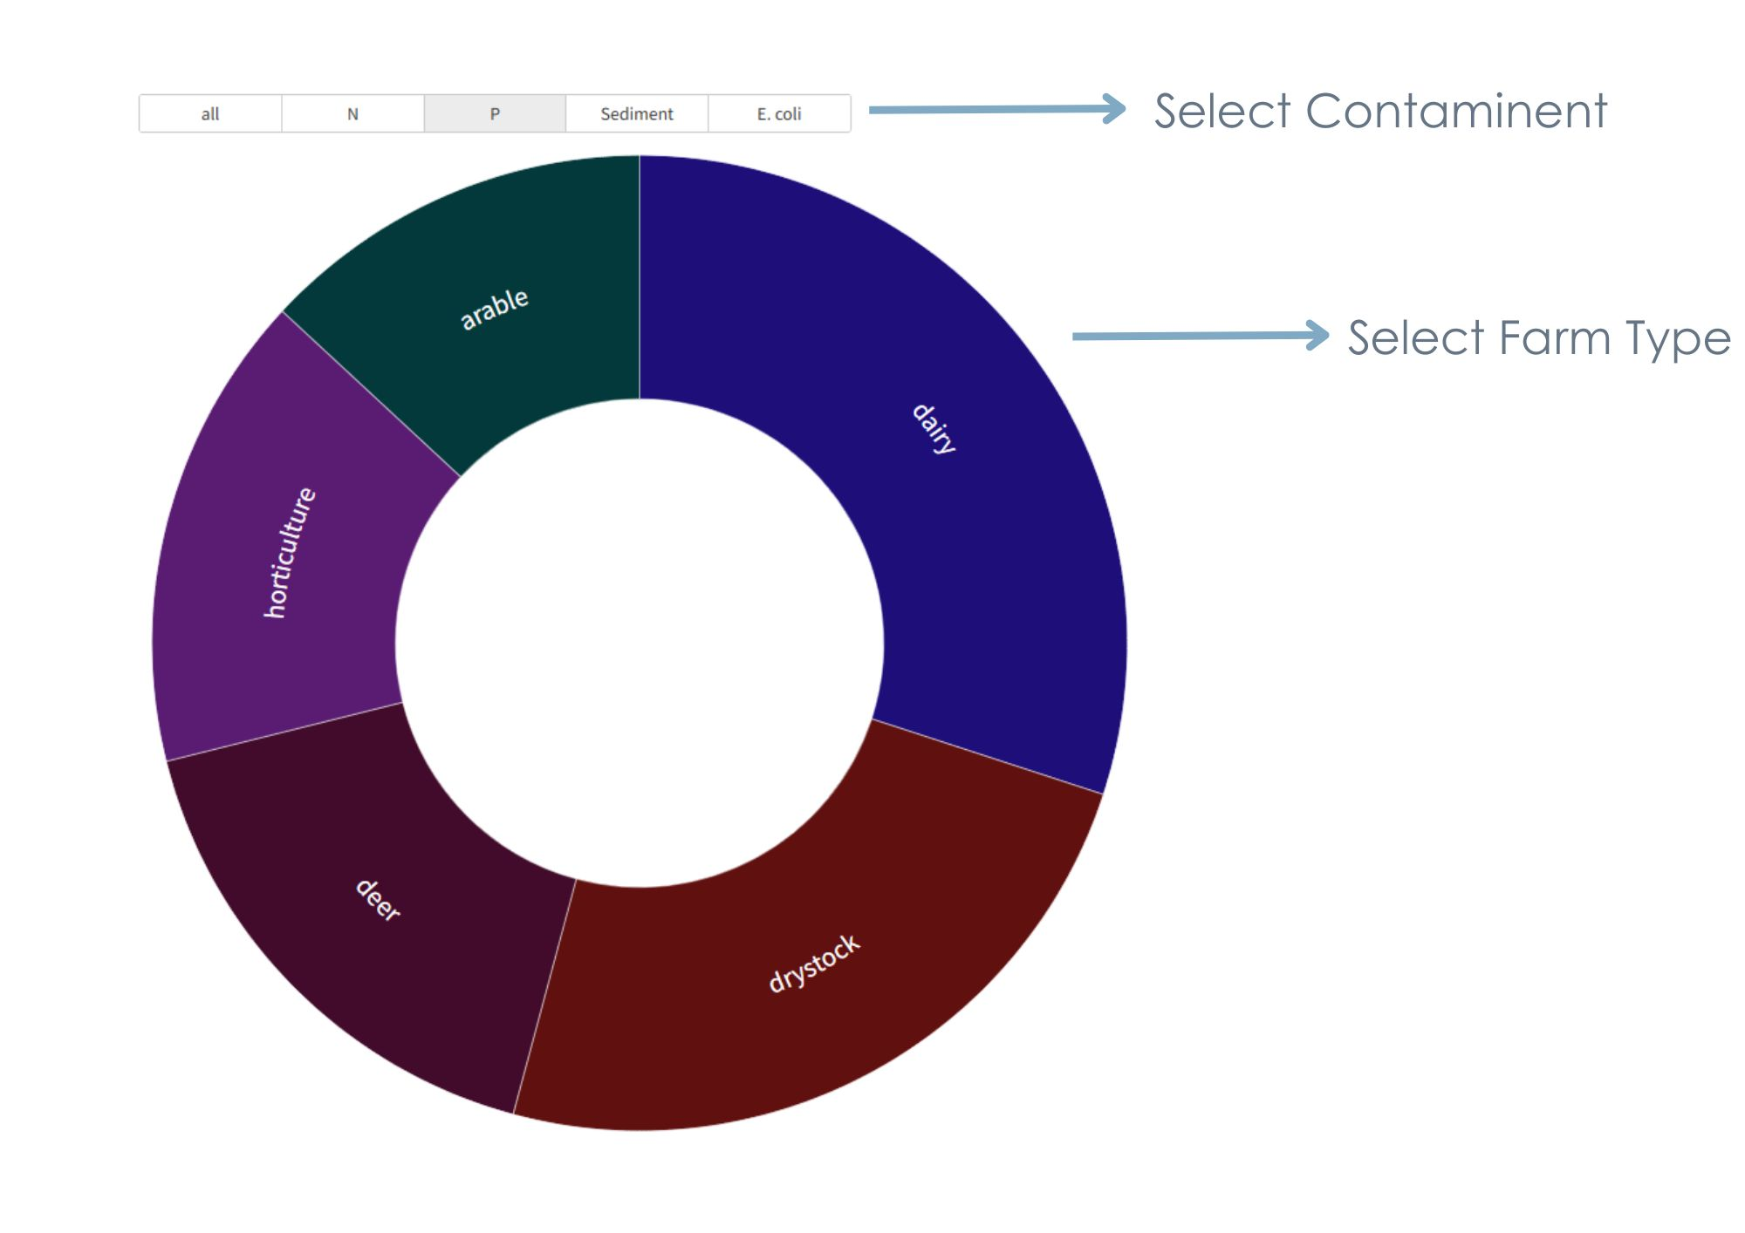
- Click the red arrow to reset your selections.

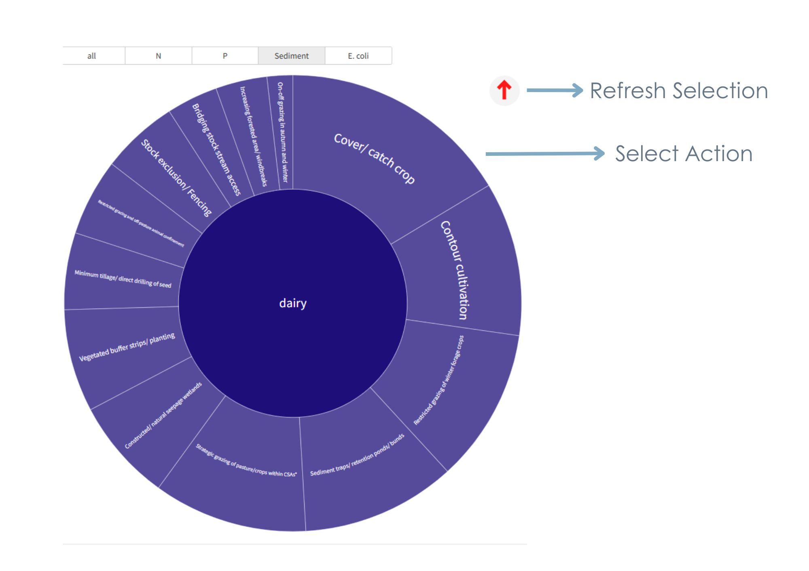

2 Appendix 2 - Understanding Highly Erodible Areas

2.1 Highly erodible areas using mapping
Each catchment in the Tukituki has been mapped using LiDAR and the revised universal soil loss equation (RUSLE) has been applied. The equation, described in IECA as having the following form: A=R·K·LS·C·P where A is the annual soil loss due to erosion (t/ha year); R the rainfall erosivity factor; K the soil erodibility factor; LS the topographic factor derived from slope length and slope gradient; C the cover and management factor; and P the erosion control practice factor. The limitations of RUSLE are that it only accounts for soil loss through surface erosion (sheet and rill erosion) and ignores the effects of gully erosion.
This model enables understanding of the highest risk areas within the catchment, where soil loss is mostly likely and where to prioritise soil conservation measures
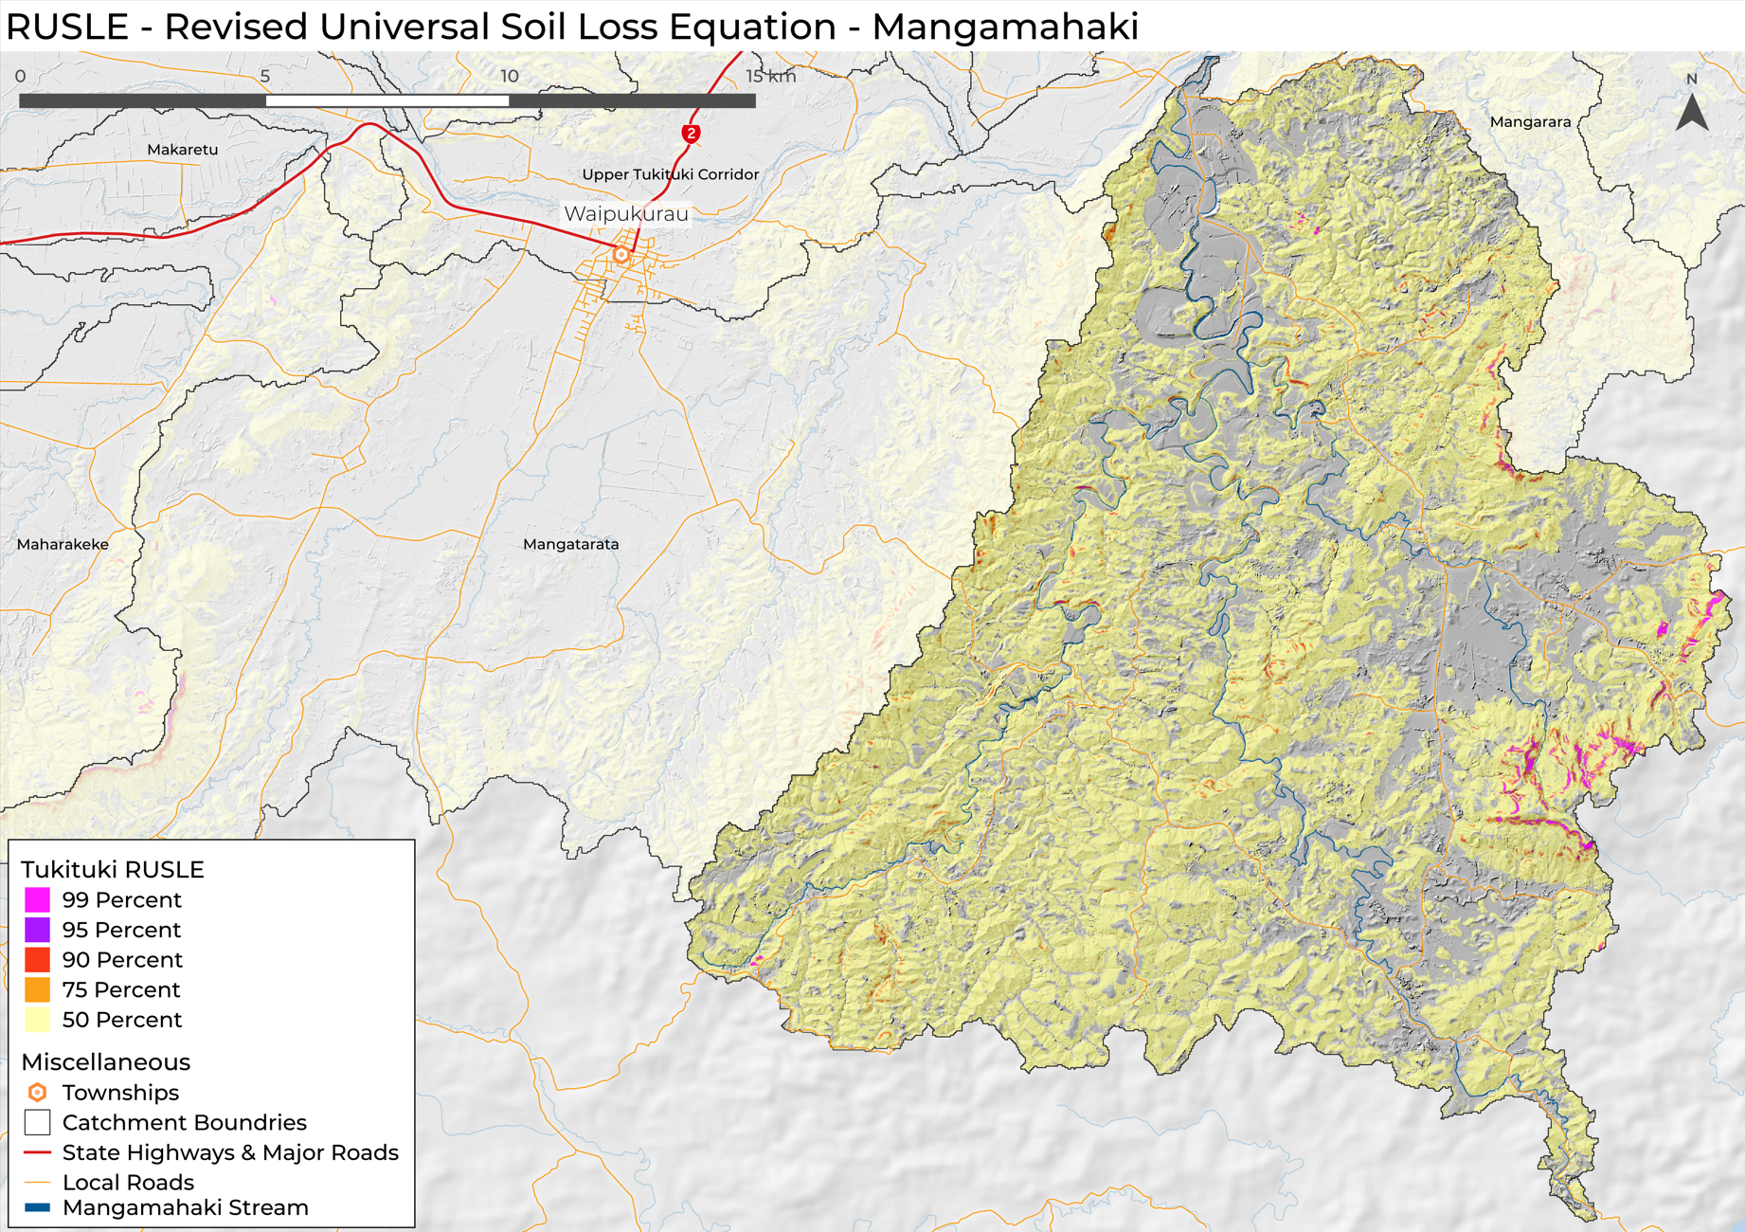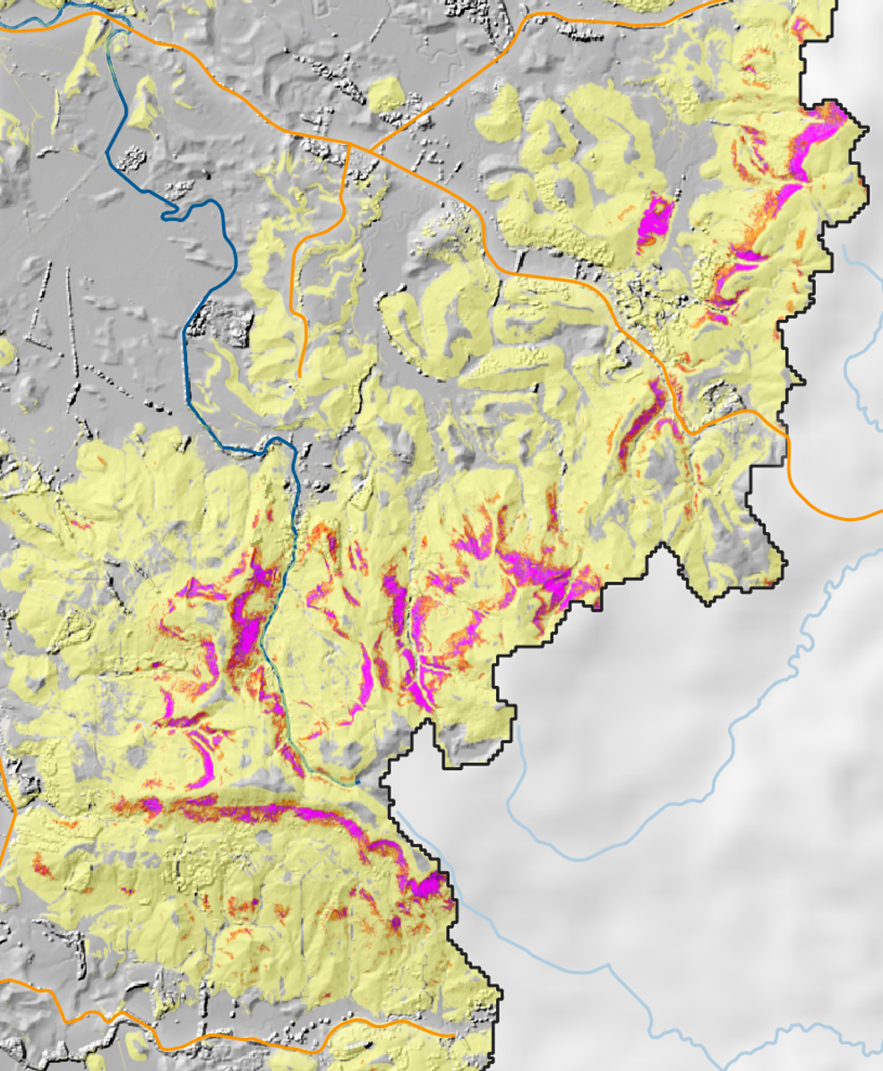

Figure 8 – RUSLE model at sub catchment scale. High risk erosion is mapped at 99%, 95%, 90%, 75% and 50%, throughout the Tukituki catchment.

2.2 Farm planning using RUSLE
As HBRC’s high resolution LiDAR data set enables high resolution mapping and prioritisation of action at Tukituki, sub catchment and farm scale. If erosion, sediment or phosphorus is a priority for the sub- catchment, using this model will help find the areas to prioritise.
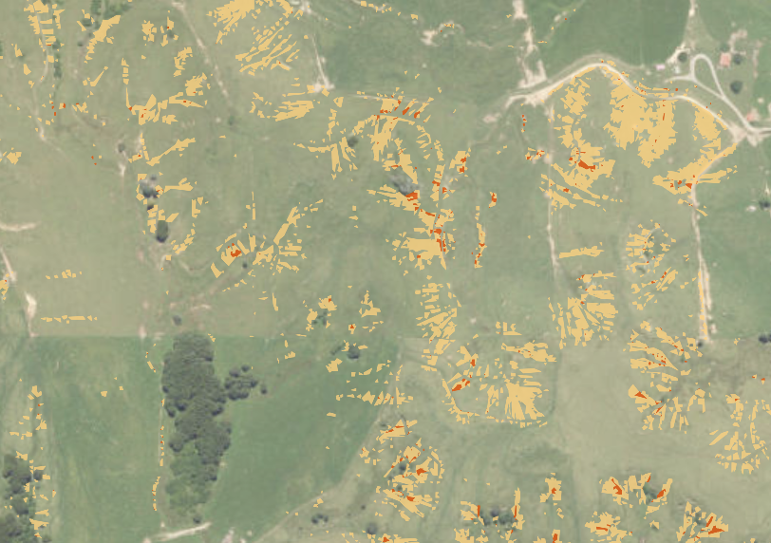
Figure 9 – From a farm planning point of view the RULSE can be used to prioritise areas to implement soil conservation measures at paddock scale.

3 Appendix 3 Flow mapping to understand sites for sediment trapping

3.1 Identification of sites for edge of field mitigations (wetlands, bunds, dams)
Topographic Wetness Index (TWI) is a measure of how likely an area is to accumulate and retain water based on its slope and contributing upslope area. TWI identifies wet or poorly drained areas in a landscape, making it useful for understanding placement of edge of field mitigations like bunds and wetlands.
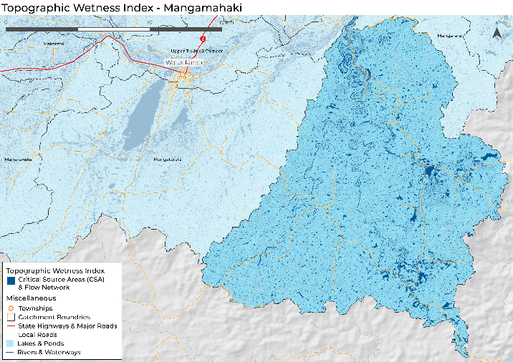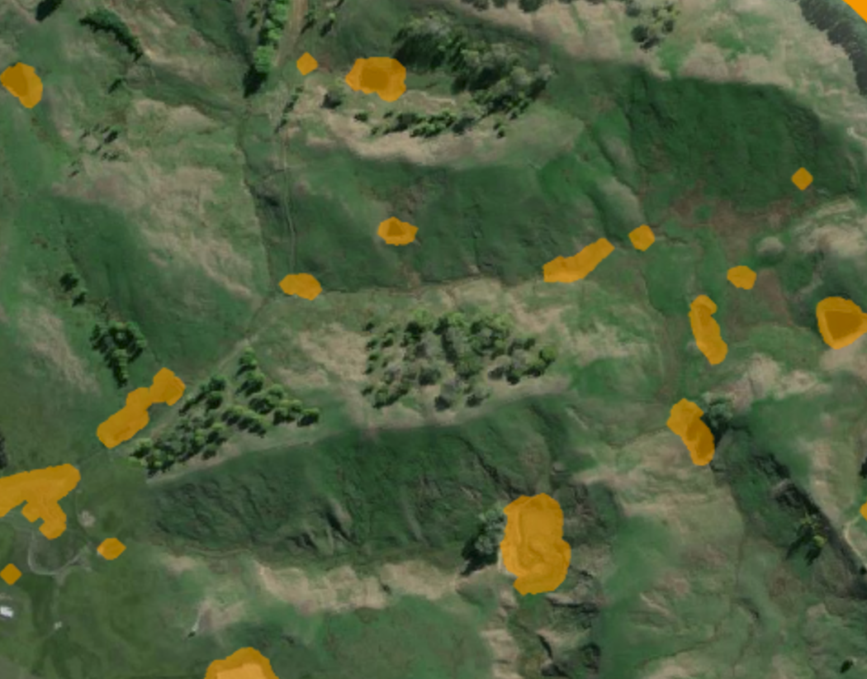

Figure 10- TWI example in a sub catchment. Using the data layers supplied by EIS will enable exploration of the data using GIS or Google Earth.
TWI can be a very useful tool in catchment and farm planning for those wanting to implement over and above farm actions. It does need ground truthing but can be useful in finding appropriate sites, with an estimate of water accumulation areas and volumes.
It is important to note that the edge of field mitigation needs to suit the outcome each catchment is seeking. TLC will have to be aware of single focus edge of field, which has become a common narrative in New Zealand. For example, promotion of single solutions like installing only constructed wetlands or detention bunds (detainments bunds) was common in freshwater management during the 2010s. 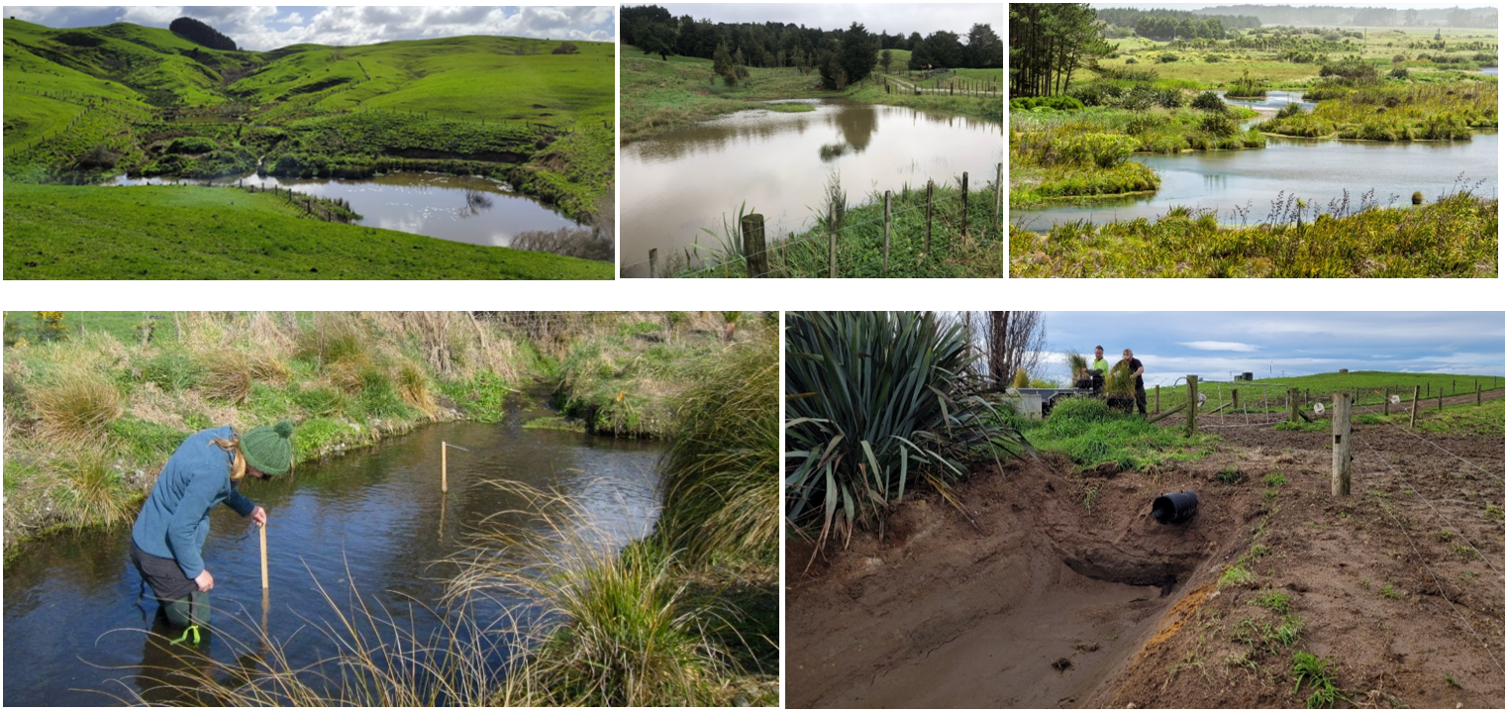
Figure 11 – Examples of edge of field mitigations, from large detention bunds, large wetlands through to in-line or off-line sediment.

Milling Poplars factsheet - https://www.tukitukilandcare.org/_files/ugd/ffabea_0d82308155b04d21a2964396525509b8.pdf
https://www.hbrc.govt.nz/environment/farmers-hub/in-the-tukituki-catchment/tukituki-dashboard/hawea-dashboard/
Lambert, M. G., Trustrum, N. A., Costall, D. A., & Foote, A. G. (1993, January). Revegetation of erosion scars in Wairarapa hill country. In Proceedings of the New Zealand Grassland Association (pp. 177-181).
Walsh PJ, Soliman, Wiercinski B 2021. The benefits and costs of erosion control in New Zealand: estimates for policy analysis. Manaaki Whenua Landcare Research Contract Report: LC3924, prepared for MBIE Endeavour Programme “Smarter Targeting of Erosion Control”.
Phillips, C. (2005, September). Erosion and sediment control using New Zealand native plants—what do we know. In Proc Erosion Control Seminar, Protecting the environment as an asset. NZ Institute of Highway Technology (pp. 11-13).
sourced from https://verdantiaresearch.co.nz/).
Moreno, G. Response of understorey forage to multiple tree effects in Iberian dehesas. Agric. Ecosyst. Environ. 123, 239–244 (2008). Gea-Izquierdo, G., Montero, G. & Cañellas, I. Changes in limiting resources determine spatio-temporal variability in tree–grass interactions. Agrofor. Syst. 76, 375–387 (2009).
Peri, P. L. Patagonia Sur. Sistemas Silvopastoriles en Ñirantales. IDIA XXI For. 5, 245–249 (2005).
Bahamonde, H. A., Peri, P. L., Martínez Pastur, G. & Lecinas, M. V. Variaciones microclima´ticas en bosques primarios y bajo uso silvopastoril de Nothofagus antarctica en dos Clases de Sitio en Patagonia Sur. in Proceedings of the 1st National congress of silvopastoral systems 14–16 (INTA Editions, Misiones, 2009).
Retiring Farmland into Ngahere Alison Dewes, John Burke, Bronwyn Douglas and Steff Kincheff Funded by Our Land and Water Science Challenge (2022)

